Working With Dataset

# Serum Cholesterol Levels Vs Age

| Team ID | PNT2022TMID04459 |
| --- | --- |
| Project Name | Visualizing and Predicting Heart Diseases with an Interactive Dashboard |

## Visualization:

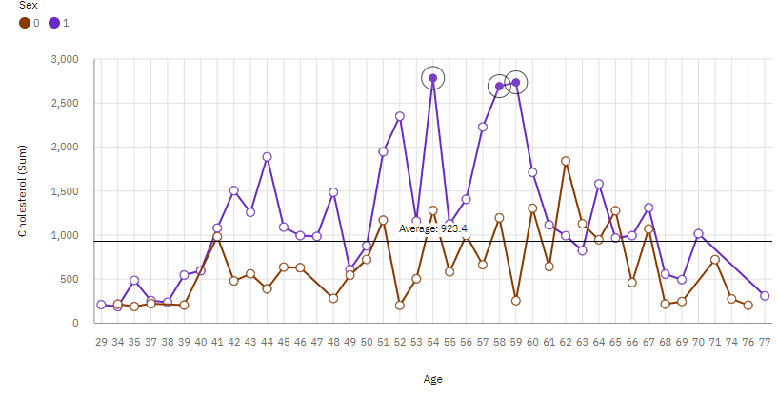

1. For **Cholesterol**, the most significant values of **Age** are 54 and 58, whose respective **Cholesterol** values add up to nearly eight thousand, or 11.8 % of the total.
2. **Cholesterol** is unusually high when the **Age** is 54 and 58.
3. For **Cholesterol**, the most significant value of **Sex** is 1, whose respective **Cholesterol** values add up to over 44 thousand, or 65.8 % of the total.
4. **Cholesterol** is unusually high when the combinations of **Age** and **Sex** are 54 and 1, 59 and 1 and 58 and 1.